**[Cheapest Flights Within K Stops](https://leetcode.com/problems/cheapest-flights-within-k-stops/)**

There are n cities connected by some number of flights. You are given an array flights where flights[i] = [fromi, toi, pricei] indicates that there is a flight from city fromi to city toi with cost pricei.

You are also given three integers src, dst, and k, return ***the cheapest price****from*src*to*dst*with at most*k*stops.*If there is no such route, return-1.

**Example 1:**

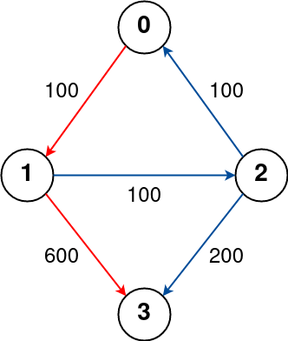

**Input:** n = 4, flights = [[0,1,100],[1,2,100],[2,0,100],[1,3,600],[2,3,200]], src = 0, dst = 3, k = 1

**Output:** 700

**Explanation:**

The graph is shown above.

The optimal path with at most 1 stop from city 0 to 3 is marked in red and has cost 100 + 600 = 700.

Note that the path through cities [0,1,2,3] is cheaper but is invalid because it uses 2 stops.

**Example 2:**

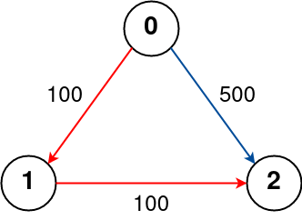

**Input:** n = 3, flights = [[0,1,100],[1,2,100],[0,2,500]], src = 0, dst = 2, k = 1

**Output:** 200

**Explanation:**

The graph is shown above.

The optimal path with at most 1 stop from city 0 to 2 is marked in red and has cost 100 + 100 = 200.

**Example 3:**

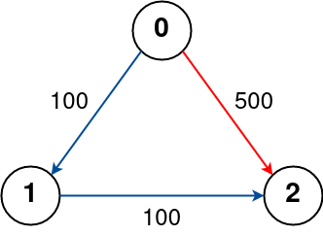

**Input:** n = 3, flights = [[0,1,100],[1,2,100],[0,2,500]], src = 0, dst = 2, k = 0

**Output:** 500

**Explanation:**

The graph is shown above.

The optimal path with no stops from city 0 to 2 is marked in red and has cost 500.

**Constraints:**

* 1 <= n <= 100
* 0 <= flights.length <= (n * (n - 1) / 2)
* flights[i].length == 3
* 0 <= fromi, toi < n
* fromi != toi
* 1 <= pricei <= 104
* There will not be any multiple flights between two cities.
* 0 <= src, dst, k < n
* src != dst

class Solution {

public:

    int findCheapestPrice(int n, vector<vector<int>>& flights, int src, int dst, int k) {

        unordered_map<int, vector<pair<int, int>>> adj;

        for (auto& flight : flights) {

            adj[flight[0]].push_back({flight[1], flight[2]});

        }

        vector<int> dist(n, INT_MAX);

        dist[src] = 0;

        queue<pair<int, int>> q;

        q.push({src, 0});

        int stops = 0;

        while (!q.empty() && stops <= k) {

            int sz = q.size();

            while (sz-- > 0) {

                auto [node, distance] = q.front();

                q.pop();

                if (!adj.count(node)) continue;

                for (auto& [neighbour, price] : adj[node]) {

                    if (price + distance >= dist[neighbour]) continue;

                    dist[neighbour] = price + distance;

                    q.push({neighbour, dist[neighbour]});

                }

            }

            stops++;

        }

        return dist[dst] == INT_MAX ? -1 : dist[dst];

    }

};

Link : <https://leetcode.com/problems/cheapest-flights-within-k-stops/?envType=daily-question&envId=2024-02-23>